Clash of Titans: E1 vs. E2 Mechanisms for a Dehydration of a Secondary Alcohol. Which one will survive under the Thermodynamic Simulations?

Yekaterina Fyodorova⁎, Dalia Hassan, Natalie Williams, Jonathan Yuan

Chemistry Department, St. John’s University

8000 Utopia Parkway, Jamaica, NY 11439

Keywords: Thermodynamics, E1, E2, Enthalpy, Entropy

ABSTRACT:

For this experiment, we have analyzed two types of elimination reactions, E1 and E2. The goal was to find which one of the two would be the most thermodynamically favorable to complete dehydration of (1H)​-​Naphthalenone, octahydro-​3-​hydroxy-​4a,​8a-​dimethyl. Through the organic chemistry prism, one would assume that the E1 mechanism is the best for this reaction, due to the weak base/weak nucleophile. The experiment’s calculations were performed with Gaussian-161. Free energy, internal energy, enthalpy, and entropy data were retrieved and analyzed. As a result, the initial assumption had to be dropped, and it was confirmed that the E2 mechanism works better for this reaction. It is not clear if the calculations accounted for all of the conditions of the reaction, but the claim was based on the retrieved data.

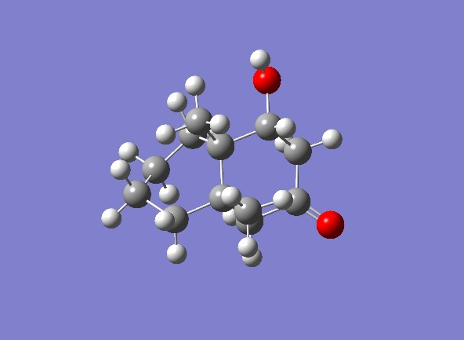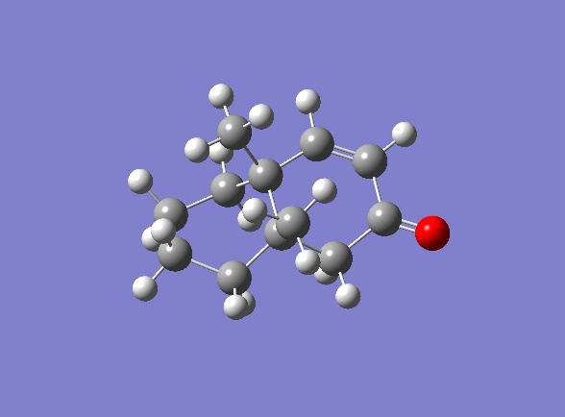

Figure 1. Initial Reactant of both presented mechanisms, represented in the Gaussian program

Figure 2. Final Product of both presented mechanisms, represented in the Gaussian program

INTRODUCTION:

In this experiment, our goal is to look at two mechanisms, E1 (Figure 3) and E2 (Figure 4), both of which show dehydration of (1H)​-​Naphthalenone, octahydro-​3-​hydroxy-​4a,​8a-​dimethyl. Our goal is to determine which mechanism would be the most thermodynamically stable and therefore, would most likely occur. By definition, the E1 mechanism occurs in a 2-step manner, and it usually occurs with a weak base. And the opposite works for the E2 mechanism, where it occurs in a 1-step manner with a strong base.3 The proposed mechanisms for our reactant are shown below in Figures 3 and 4. E2 mechanism requires a specific anti-coplanar orientation of the nucleophile to the leaving group. The concept behind mechanism E1 is that it forms a carbocation that is stabilized the most with the polar solvents.3 Since our reaction occurs in an aqueous environment, and we know that water is not a strong nucleophile and is polar solvent, the assumption was made that the reaction will prefer to undergo E1 mechanism. To figure out the truthfulness of our assumption, calculations will be performed on Gaussian-16 (see details in the next section).1



Figure 3: Steps for the dehydration of a molecule through E1 mechanism (two-steps, has a carbocation intermediate).



Figure 4: Steps for the dehydration of a molecule through E2 mechanism (one-step, immediate).



Figure 5. The structure of the initial reactant that shows all stereochemical centers. Note that this report will be discussing the results for the structure that had all the group’s stereocenters pointing up (UUU).

From the computational results, we are expecting to get the data that will allow us to employ the Gibbs Free Energy equation (1), which identifies the reaction as favored or disfavored.4

ΔG = ΔH – TΔS (1)

Based on our assumption, we expect values for free energy, enthalpy, entropy, and internal energy within each step of the reaction to be lower for the E1 mechanism than for corresponding values for the E2 mechanism. But for the overall reaction, the values have to be the same.

COMPUTATIONAL DETAILS:

We have looked at the performance of the reactant of the dehydration reaction in both mechanisms (E1 and E2) through the density functional theory (DFT). The calculations were performed by employing the program called Gaussian-16.1 Overall, each reactant of the mechanisms went through seven steps of differently conditioned calculations. Note that some of the steps of the reaction repeat in both of the mechanisms, therefore, calculations for those steps were carried out once. At first, Hartree-Fock (HF) method was used to run the optimization of all steps with the basis set 3-21G. Next, a series of energy calculations were accomplished by using DFT method with basis sets, 3-21G, 6-31G, 6-311G, 6-311G(2d), 6-311G(2d,2p). Finally, each step of the reaction was analyzed for optimization + frequency DFT-B3LYP calculation with the basis set 6-311G(2d,2p).2 Each of the constructed molecules in Gaussian had to follow this order of the calculations because each forward step depended on the data retrieved from the step before.

RESULTS and DISCUSSION:

The raw and calculated data below showed that our assumption about the E1 mechanism being the best for this reaction was wrong, and the E2 in fact would rather perform this dehydration reaction.

Table 1: Retrieved data from Gaussian-161 for the E1 mechanism.

|  |  |  |  |  |
| --- | --- | --- | --- | --- |
| **E1** | | | | |
|  | **B1 - A** | **C1 - B1** | **D1 - C1** | **Overall** |
| **ΔG (kcal/mol)** | -31.4 | -16.77 | 39.87 | -8.3 |
| **ΔU (kcal/mol)** | -32.44 | -15.86 | 37.91 | -10.38 |
| **ΔS (kcal/mol×K)** | -0.0043 | 0.0481 | -0.0057 | 0.0382 |
| **ΔH (kcal/mol)** | -32.7 | -2.41 | 38.17 | 3.06 |

Table 2: Retrieved data from Gaussian-161 for the E2 mechanism.

|  |  |  |  |
| --- | --- | --- | --- |
| **E2** | | | |
|  | **B2-A** | **D2-B2** | **Overall** |
| **ΔG (kcal/mol)** | -31.4 | 23.1 | -8.3 |
| **ΔU (kcal/mol)** | -31.4 | 23.1 | -8.3 |
| **ΔS (kcal/mol×K)** | -0.0043 | 0.0425 | 0.0382 |
| **ΔH (kcal/mol)** | -32.7 | 35.76 | 3.06 |

Table 3: Calculated results for the entropy part of the Gibb’s Free Energy equation for both the E1 and the E2 mechanisms.

|  |  |  |  |
| --- | --- | --- | --- |
| **E1** | | | |
| **TΔS (kcal/mol) (B1 - A)** | **TΔS (kcal/mol) (C1 - B1)** | **TΔS (kcal/mol) (D1 - C1)** | **TΔS (kcal/mol) Overall** |
| -1.27 | 14.36 | -1.699 | 11.39 |
| **E2** | | | |
| **TΔS (kcal/mol) (B2 - A)** | **TΔS (kcal/mol) (D2 - B2)** |  | **TΔS (kcal/mol) Overall** |
| -1.27 | 12.66 |  | 11.39 |

Figure 6. The Gibb’s Free Energy Plot represents free energy for each step of both mechanisms. This plot clearly shows that the E2 is more favorable mechanism for the presented reaction.

From the Tables 1 and 2, we can see that both mechanisms give us overall reaction that is spontaneous, since the overall free and internal energies for both mechanisms resulted in a negative value. However, if we look at each step, we can see that some of them result in positive free energy values, like step D1-C1 for the E1 mechanism and D2-B2 for the E2 mechanism. These steps are the key to determining the favorable mechanism, because it shows that E2 mechanism requires much less energy to get to the final product than the E1 mechanism, thus it is more stable. Figure 6 represents that claim in the form of Gibb’s Free Energy plot diagram. Consequently, we reject our initial assumption and claim that even through organic chemistry the reaction would undergo E1, thermodynamically, it would rather follow E2 mechanism.

One can also tell that the enthalpy and entropy of the overall reaction is positive, but free energy and internal energy overall values are negative, therefore, we can tell that the reaction is endothermic. Moreover, from the Table 3 data, which shows values for the entropy term of the Gibb’s equation, we can see that the overall reaction is entropically driven since the TΔS value is much higher than the ΔH value. That means that the temperature at which the experiment was performed at had to be high enough to still make the overall reaction in both mechanisms spontaneous. All of our computational experiments were ran at room temperature, which in this case is high enough to make the reaction spontaneous. It is important to note that not all of the steps of the reaction were entropically driven. In the E2, step D2-B2 is enthalpically driven because ΔH is greater than the entropy term TΔS. In the E1, the last step of the mechanism D1-C1 is also enthalpically driven due to the ΔH term being greater than the entropy term TΔS.

CONCLUSION:

The results of this experiment turned out to be different from what we have expected. That could be due to the computational techniques and conditions that we have used for running the calculations. It also could be that this specific reactant prefers the E2 mechanism over the E1 mechanism. From the retrieved data, the initial assumption had to be omitted and we concluded that the E2 mechanism is the best for the dehydration of the (1H)​-​Naphthalenone, octahydro-​3-​hydroxy-​4a,​8a-​dimethyl.

BIBLIOGRAPHY:

1. Gaussian 16, Revision C.01, Frisch, M. J.; Trucks, G. W.; Schlegel, H. B.; Scuseria, G. E.; Robb, M. A.; Cheeseman, J. R.; Scalmani, G.; Barone, V.; Petersson, G. A.; Nakatsuji, H.; Li, X.; Caricato, M.; Marenich, A. V.; Bloino, J.; Janesko, B. G.; Gomperts, R.; Mennucci, B.; Hratchian, H. P.; Ortiz, J. V.; Izmaylov, A. F.; Sonnenberg, J. L.; Williams-Young, D.; Ding, F.; Lipparini, F.; Egidi, F.; Goings, J.; Peng, B.; Petrone, A.; Henderson, T.; Ranasinghe, D.; Zakrzewski, V. G.; Gao, J.; Rega, N.; Zheng, G.; Liang, W.; Hada, M.; Ehara, M.; Toyota, K.; Fukuda, R.; Hasegawa, J.; Ishida, M.; Nakajima, T.; Honda, Y.; Kitao, O.; Nakai, H.; Vreven, T.; Throssell, K.; Montgomery, J. A., Jr.; Peralta, J. E.; Ogliaro, F.; Bearpark, M. J.; Heyd, J. J.; Brothers, E. N.; Kudin, K. N.; Staroverov, V. N.; Keith, T. A.; Kobayashi, R.; Normand, J.; Raghavachari, K.; Rendell, A. P.; Burant, J. C.; Iyengar, S. S.; Tomasi, J.; Cossi, M.; Millam, J. M.; Klene, M.; Adamo, C.; Cammi, R.; Ochterski, J. W.; Martin, R. L.; Morokuma, K.; Farkas, O.; Foresman, J. B.; Fox, D. J. Gaussian, Inc., Wallingford CT, **2016**.
2. Stephens, P. J.; Devlin, F. J.; Chabalowski, C. F.; Frisch, M. J. *J. Phys. Chem.***1994**, *98*, 11623−11627.
3. Comparison of E1 and E2 Reactions. Chemistry Libretexts. [Online]. <https://chem.libretexts.org/Bookshelves/Organic_Chemistry/Map%3A_Organic_Chemistry_(Wade)/07%3A_Alkyl_Halides%3A_Nucleophilic_Substitution_and_Elimination/7.18%3A_Comparison_of_E1_and_E2_Reactions>
4. Gibb’s Free Energy. [Online]. <http://www.softschools.com/notes/ap_chemistry/gibbs_free_energy/>